**System and hardware information**

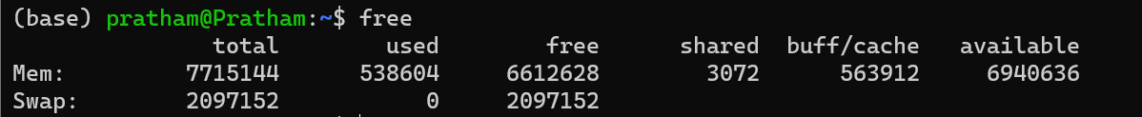

**User information and management**

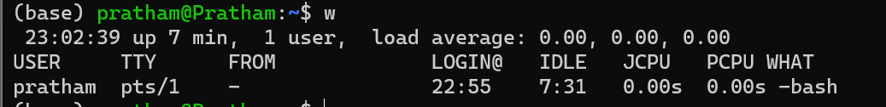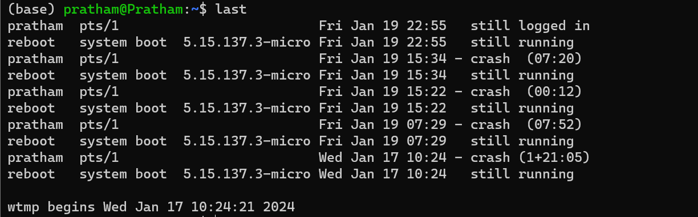

**File and directory commands**

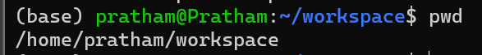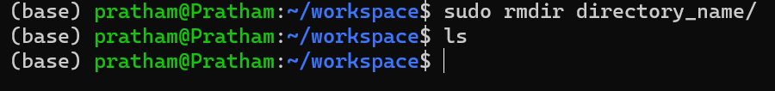

**File permissions**



**Archives (TAR files)**

**Directory navigation**

**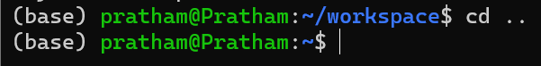  
**

**Process management  
**

**Networking**

**File transfers**

**Search**

**File editing**



**Disk usage**

